

Chapter 3. Managing User Accounts

**OTCnet Participant User Guide**

**Table of Contents**

Overview, Topics, and Audience 1

Overview 1

Topics 1

Audience 1

Topic 1 The Purpose of Managing User Accounts 2

Topic 2 Creating a User Identity (User ID) 3

Create a User ID 3

*Create a User Identity (User ID) 4*

Topic 3 Creating, Assigning and Editing an OTCnet Account 7

Create and Edit an OTCnet Account 7

*Create and Edit an OTCnet Account 8*

Topic 4 Managing a User Password 12

Manage a User Password 12

*Manage a User Password 13*

Topic 5 Managing Personal Information 15

Manage Personal Information 15

*Manage Personal Information 16*

Topic 6 Approving or Rejecting an OTCnet User Request 18

Approve or Reject an OTCnet User Request 18

*Approve or Reject an OTCnet User Request 19*

Topic 7 Modifying User Status 20

Modify User Status 20

*Modify User Status 21*

Summary 23

List of Figures

Figure 1: Log in to ISIM 4

Figure 2: New External User Identity 4

Figure 3: Search Person Page (Criteria) - Person 8

Figure 4: Create Account for Page 9

Figure 5: Search Managed Organizations Page 9

Figure 6: Manage User Page 13

Figure 7: Manage User Page - Personal Info 16

Figure 8: Approve/Reject the Request Page 19

Figure 9: Request Management- Your-To-Do List (Account Approval) 22

**Glossary**

Click this [link](https://www.fiscal.treasury.gov/otcnet/training/wbt/content/course_OTC/library.htm) to access the full OTCnet Glossary.

# Overview, Topics, and Audience

## Overview

Welcome to *Managing User Accounts*. In this chapter, you will learn:

* The purpose of managing user accounts
* How to identify users who are authorized to manage other user accounts
* How to create a User Identity (User ID)
* How to create, assign and edit an OTCnet account for a user
* How to manage a user password
* How to manage personal information
* How to approve/reject an OTCnet user request
* How to modify a user status

## Topics

This topics in this chapter include the following:

1. The Purpose of Managing User Accounts
2. Creating a User Identity (User ID)
3. Creating, Assigning and Editing an OTCnet Account
4. Managing a User Password
5. Managing Personal Information
6. Approving or Rejecting an OTCnet User Request
7. Modifying User Status

## Audience

The intended audience for the Managing User Accounts Participant User Guide includes:

* + Primary Local Security Administrator (PLSA)
  + Local Security Administrator (LSA)

*Chapter 3. Managing User Accounts*

# Topic 1 The Purpose of Managing User Accounts

As the **Primary Local Security Administrator (PLSA)** or **Local Security Administrator (LSA)**

for your organization, you are authorized to manage the users who have access to OTCnet. Before a user can access OTCnet, you must access IBM Security Identity Manager (ISIM) through OTCnet Online.

Managing a user’s account involves (in order):

1. Creating a User Identity (User ID)
2. Creating, assigning, and updating an OTCnet account for a user
3. Managing the user password

The three steps referenced above are necessary to ensure that a user can access OTCnet. Creating a new User ID is only necessary if a user does not already have a Fiscal Service Single Sign On User ID. A temporary password is automatically sent to the user’s email address after the User ID is created.

Managing a user’s password is only required for resetting a user’s password (typically reset by the **Primary/Local Security Specialist (P/LSA)** if a user forgets his/her password).

# Topic 2 Creating a User Identity (User ID)

Creating the User ID is the *first* step in managing a user’s access to OTCnet, if a user does not already have an existing Fiscal Service Single Sign On (SSO) account. After you create the User ID, create and assign an OTCnet account to the User ID, you can then manage the user’s password so he/she can access OTCnet (in this order).

After you create the User ID, create and assign an OTCnet account to the User ID, you will manage the user’s password so he/she can access OTCnet (in this order).

Creating a User ID does not require approval from another **PLSA** or **LSA**. Upon successful creation of a User ID, the user receives an email notification containing information about his/her new User ID.

To create a User ID, you must enter the user’s personal information such as name, agency name, and the application name (OTCnet) of the user.

## Create a User Identity (User ID)

To create a User ID, you will log in to OTCnet by selecting **Administration** and **Manage Users**. One the ISIM log-in page appear, you will log in to ISIM with your OTCnet credentials. Next, you will create a new external identity by entering the user’s personal information details.

The **Generation Identifier/Suffix** and **Organizational Roles** details are not applicable. The

**Organizational Roles** details populates after the User ID is successfully created.

You will search for the organization name under **Corporate** and add the organization. You will then search for the user’s primary base location, enter the **Contact** details and schedule the User Identity to be created.

**Create a User Identity (User ID)**

To create a user identity, complete the following steps:

1. Log in to OCTnet—from **Administration,** select **Manage Users**.
2. Log in to ISIM with your OTCnet credentials as shown in Figure 1.The *Request Management-Your To-Do List* page appears.

**Figure 1: Log in to ISIM**

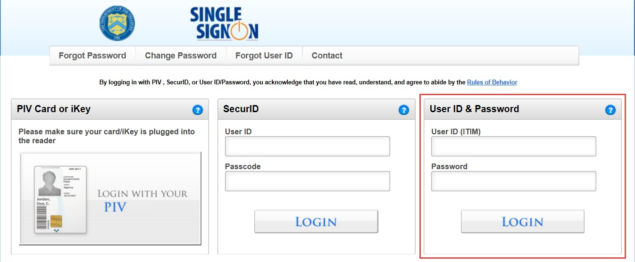

1. From the main menu bar, select **Organization** and click **New External User Identity**. The

*New External Identity* page appears, as shown in Figure 2.

**Figure 2: New External User Identity**

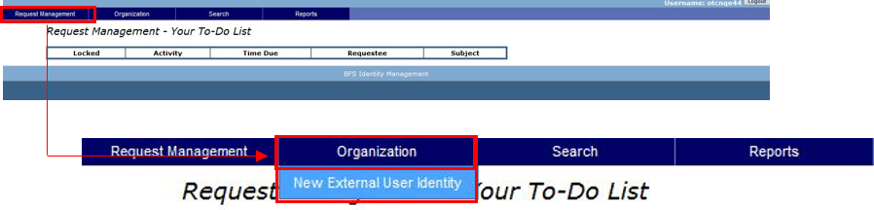

1. Under the **External** tab, enter your personal information details:
   * **Legal Prefix**
   * **Legal Name**, required
   * **Legal First Name**, required
   * **Legal Middle Name**
   * **Legal Last Name**, required

**Application Tip**

The **Generation Identifier/Suffix** and **Organizational Roles** details are not applicable. The **Organizational Roles** details populates after the user’s identity is successfully created.

1. Click the **Corporate** tab.
2. From **Identity Organization**, click **Search**. The *Search: Identity Organization* dialog box appears.
3. Enter the organization name in the text box and click **Search**.

**Application Tip**

If you do not know the full name of the organization, enter a partial name search.

1. From the resulting list, click the organization name that you wish you to add.
2. Scroll to the bottom of the dialog box and click **Add** and **Done**.
3. From **Sponsoring Application**, click **Search**. The *Search: Sponsoring Application* dialog box appears.

**Application Tip**

The **Primary Location** search functionality is optional to identify the user’s primary base location. The steps mirror those of *Sponsoring Application*.

1. Select **OTCnet (SSO)** from the list.
2. Scroll to the bottom of the dialog box and click **Add** and **Done**.
3. Click the **Contact** tab.
4. Enter the appropriate contact details:
   * Enter an **Email Address**, *required*
   * Enter a **Mobile Phone**
   * Enter an **Office Phone**, *required*
   * Enter a **Pager number**
   * Enter an **Office Fax Number**
   * Enter an **Office Room Number**, *if applicable*
   * Enter an **Office Street address**, *required*
   * Enter an **Office Street Address 2**, *if applicable*
   * Enter a **City**, *required*
   * Enter an **Office State**, *required*
   * Enter an **Office Postal Code**, *required*
   * Enter an **Office Country**, *required*

**Application Tip**

The **Telephone Number** field may not include special characters including, but not limited to hyphens, periods, spaces, and parenthesis.

1. Click the **Schedule for Now** or **Schedule for Later** radio button.

**Application Tip**

If the **Schedule for Later** radio button is selected, enter the **Date** and **Time** the ID should be created.

1. Click **Submit**. The *Request Management – Your Pending Requests* page appears.

**Application Tip**

To verify creation of a new identify, select **Request Management**, and click the **View Pending Requests** or **View Completed Requests**.

# Topic 3 Creating, Assigning and Editing an OTCnet Account

You can create and assign an OTCnet account to a user only ***after*** the User ID is created. When creating an OTCnet account, assign more than one role to a user. For example, assign a user both the **Deposit Preparer** and **Deposit Approver** roles. You can edit a user’s account only after the OTCnet account is assigned to the user.

After a **PLSA** or **LSA** creates and assigns an OTCnet account to a user, **ISIM** looks for other approvers within the same OTC Endpoint or hierarchy and notifies them of the pending request. Approvers are other **PLSAs** and **LSAs** that exist in the same OTC Endpoint, or hierarchy, as the requestor.

## Create and Edit an OTCnet Account

To create and edit an OTCnet account, you will first search for the person from the main menu bar, using the **External** option and search for the person with your designated search criteria. You will select the hyperlink for the name of the user for whom you will create and assign an OTCnet account, via **Manage Accounts**.

To create a new OTCnet user account, you will click **New** or you can modify an existing OTCnet account for a user and click the **User ID** hyperlink for the OTCnet account. You’ll then click **OTCnet** for the account type and **Submit** it. From **Managed Organization**, you’ll **Search** and enter the organization name in the blank text box. Next, you’ll select the name of the organization you want to add and assign permissions.

You’ll select a **Role** and an access group from the **Level 1, Level 2**, **Level 3** and **Level 4** drop- downs and **Submit**. You will schedule the account and submit it.

**Create and Edit an OTCnet Account**

To create and edit an OTCnet account for a user, complete the following steps:

1. From the main menu bar, click **Search** and select **Person**. The *Search Person* page appears.
2. From the **Select** drop-down menu, select **External**.

**Application Tip**

By default, the **Select** drop-down menu is set to **External**.

1. From the **Where** drop-down menu, select a criteria type.

**Application Tip**

By default, the **Where** drop-down menu is set to **Full Name**. Choose any option as needed.

1. Enter the search criteria in the blank text box on the right and click **Search** as shown in Figure 3. The *Search Person* page appears with the results of your search criteria.

**Figure 3: Search Person Page (Criteria) - Person**

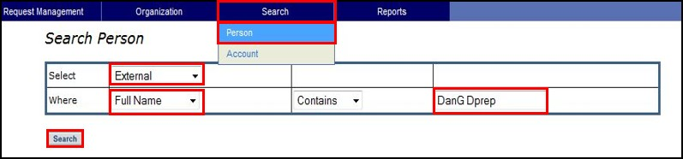

**Application Tip**

By default, the drop-down menu after **Where** is set to **Contains**. Choose any option as needed.

1. Click the **Select** hyperlink of the name of the user for which you would like to create and assign an OTCnet account. A *Manage User* page appears.
2. Click **Manage Accounts**. The *Manage Accounts* page appears.
3. To create a new OTCnet account for a user, click **New**. The *Create Account for*: page appears as shown in Figure 4.

Or

To modify an existing OTCnet account for a user, click the **User ID** hyperlink for the OTCnet account and proceed to the **Managed Organization** step below.

**Figure 4: Create Account for Page**

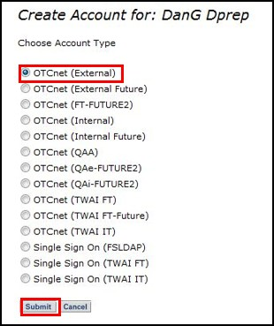

1. Click **OTCnet** for the account type. Click **Submit**. The *Edit Account: OTCnet* page appears.

**Application Tips**

* + Selecting **OTCnet** indicates that the user can log on to OTCnet.
  + Proceed to **Click to Modify** to modify the user’s role group.

1. From **Managed Organizations**, click **Search**. The *Search: Managed Organizations* dialog box appears, as shown in Figure 5.

**Figure 5: Search Managed Organizations Page**

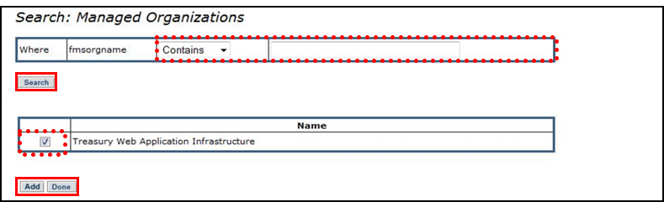

**Application Tips**

* + **Managed Organizations** is only used by **PLSAs** for creating **LSA** users. When creating any other user, this field should be left blank. **LSAs** should never use this field when creating users.
  + The name in the **Managed Organizations** field is typically the same as the Identity Organization name. The **Identity Organization** was originally used when you created the User ID.

1. Enter the organization name in the blank text box. Click **Search**.

**Application Tip**

If you do not know the full name of the organization, enter a partial name search.

1. Click the checkbox of the organization’s name you wish to add.
2. Click **Add**. Click **Done** to return to the *Edit Account: OTCnet* page.

**Application Tip**

Proceed to **Click to Modify** to modify the user’s role group. If not, proceed to **Schedule for Now** or **Schedule for Later**.

1. From **Assign Permission**, click the **Click to Modify** hyperlink. The *OTCnet Module Role Access Group* dialog box appears.

**Application Tip**

If the **Allow OTC Endpoint to create deposits for over-the-counter collections** check box and/or the **Enable Check Capture** check box is not checked when modifying OTC Endpoint Information, you cannot provision the user to the appropriate OTCnet Endpoint.

1. Select a **Role** from the **Choose a Role** drop-down.
2. Select an access group from the **Level 1** drop-down. The **Level 2** drop-down appears, *if applicable*.

**Application Tip**

Wait for the **Level 2** drop-down to appear. Since ISIM is a web application, there may be a slight delay.

1. Select an access group from the **Level 3** drop-down. The **Level 4** drop-down appears, *if applicable*.

**Application Tip**

Repeat the *Select an access group from the Level 1 drop-down. The Level 2 drop-down appears, if applicable* step, as necessary, for each successive level until you select the desired access group.

1. Click **Submit** to return to the *Edit Account: OTCnet* page.
2. Click the **Schedule for Now** or **Schedule for Later** radio button.

**Application Tip**

If the **Schedule for Later** radio button is selected, enter the **Date** and **Time** when the OTCnet account should be created.

1. Click **Submit**. The *Request Management – Your Pending Requests* page appears.

**Application Tips**

* + To add additional user roles, repeat the steps from **Assign Permission** through

**Submit**.

* + To finalize a user’s access to OTCnet, an approver (**PLSA** or **LSA**) within the same OTC Endpoint or hierarchy must approve the request.
  + To verify the account was successfully provisioned, select **Request Management** and click **View Pending Requests** or **View Completed Requests**. A request is listed as completed if an Approver has approved the request.

# Topic 4 Managing a User Password

As a **PLSA** or **LSA**, you must access **ISIM** to manage a user’s password. You can only manage a user’s password *after* the following steps occur:

1. The User ID is created
2. An OTCnet account is created and assigned to the user’s ID
3. An approver (another **PLSA** or **LSA** user within the same OTC Endpoint or hierarchy) approves the OTCnet account creation request

After an OTCnet account is created and assigned to a user (and the request is approved), you will manage the user’s password. Reset a user password using the **Manage Passwords** function. Resetting a user’s password does not require approval from another **PLSA** or **LSA**. Once the password reset is complete, an email notification is sent to the user with a temporary password.

## Manage a User Password

To manage a user password you will first search for the user in ISIM using your search criteria. You will then **Select** the hyperlink for the name of the user for whom you would like to manage the password and click **Manage Passwords**. You will select the check boxes for the **Single Sign On (FSLDAP)** and **OTCnet** services and submit your request.

**Manage a User Password**

To manage a user password, complete the following steps:

1. From the main menu bar, select **Search** and click **Person**. The *Search Person* page appears.
2. From the **Select** drop-down menu, select **External**.

**Application Tip**

By default, the **Select** drop-down menu is set to **External**.

1. From the **Where** drop-down menu, select a criteria type.

**Application Tip**

By default, the **Where** drop-down menu is set to **Full Name**. Choose any option as needed.

1. Enter the search criteria in the blank text box on the right and click **Search**. The *Search Person* page appears with the results of your search criteria.

**Application Tip**

By default, the drop-down menu after **Where** is set to **Contains**. Choose any option as needed.

1. Click the **Select** hyperlink of the name of the user for whom you would like to manage the password. A *Manage User* page appears as shown in Figure 6.

**Figure 6: Manage User Page**

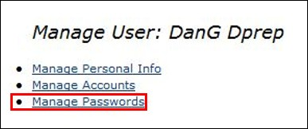

1. Click **Manage Passwords**.
2. Click the **Select** check boxes for the **Single Sign On (FSLDAP)** and **OTCnet** services.
3. Click **Submit**. A *Request submitted* message appears.

**Application Tip**

After the request to reset the password is submitted, the user receives an email with a temporary password and link to access OTCnet.

# Topic 5 Managing Personal Information

As a **PLSA** or **LSA**, you must access **ISIM** to manage a user’s personal information (e.g., external, corporate, and contact information). You can only manage a user’s personal information *after* the User ID is created.

## Manage a User’s Personal Information

To manage a user’s personal information, you must first search for the person in ISIM. You will **Select** the hyperlink of the name of the user for whom you would like to manage the password, click **Manage Personal** and update the appropriate fields from the **External, Corporate** and **Contact** tabs. Finally, you will determine whether you want to submit the user’s information now or later.

**Manage a User’s Personal Information**

To edit a user’s personal information, complete the following steps:

1. From the main menu bar, select **Search** and click **Person**. The *Search Person* page appears.
2. From the **Select** drop-down menu, select **External**.

**Application Tip**

By default, the **Select** drop-down menu is set to **External**.

1. From the **Where** drop-down menu, select a criteria type.

**Application Tip**

By default, the **Where** drop-down menu is set to **Full Name**. Choose any option as needed.

1. Enter the search criteria in the blank text box on the right and click **Search**. The *Search Person* page appears.

**Application Tip**

By default, the drop-down menu after **Where** is set to **Contains**. Choose any option as needed.

1. Click the **Select** hyperlink for the name of the user you will manage. A *Manage User* page appears.
2. Click **Manage Personal Info** as shown in Figure 7.The *Personal Information* page appears.

**Figure 7: Manage User Page - Personal Info**

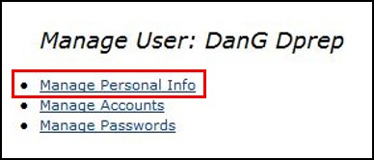

1. From the **Personal Information** page, click the following tabs and update the appropriate fields:
   * **External**
   * **Corporate**
   * **Contact**
2. Click the **Schedule for Now** or **Schedule for Later** radio button.

**Application Tip**

If the **Schedule for Later** radio button is selected, enter the **Date** and **Time** the ID should be created.

1. Click **Submit**.



**Additional Button**

Click **Cancel** to return to the ISIM Home Page. No data will be saved.

# Topic 6 Approving or Rejecting an OTCnet User Request

As a **PLSA** or **LSA** you are authorized to approve or reject an OTCnet account creation or modification request. You must access **ISIM** to approve or reject a request. You can approve or reject a request *after* another **PLSA** or **LSA** within the same OTC Endpoint or hierarchy generates the request by creating or modifying an OTCnet account for a user.

After approving the request, the user for which the OTCnet account applies, receives an email notification containing information about the changes to his/her OTCnet account. If you reject the request, the **PLSA** or **LSA** who created the request receives an **ISIM** notification of the rejection.

## Approve or Reject an OTCnet User Account

To approve or reject an OTCnet user request, you will log in to OTCnet and click **Administration** and **Manage Users**. You’ll then log in to ISIM. When the *Request Management Your To Do List* page appears, click **Account Approval**. You will **Approve**, **Reject** or **Cancel** your user request and view the details of your request.

**Approve or Reject an OTCnet User Account**

To approve or reject an OTCnet account creation or modification request, complete the following steps:

1. Log in to OTCnet and from the **Administration** tab**,** click **Manage Users**.
2. Log in to ISIM with your OTCnet credentials. The *Request Management Your To-Do List*

page appears.

1. Click **Account Approval**. The *Approve/Reject the Request* page appears as shown in Figure 8.

**Figure 8: Approve/Reject the Request Page**

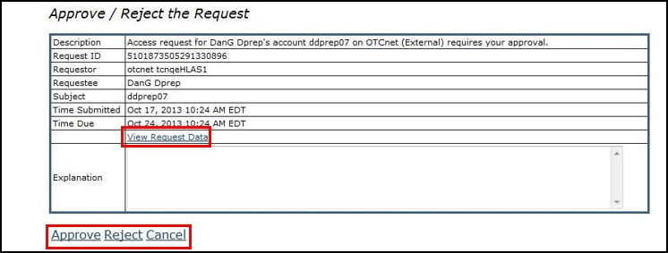

1. Click the **Schedule for Now** or **Schedule for Later** radio button.

**Application Tip**

If the **Schedule for Later** radio button is selected, enter the **Date** and **Time** for the identity to be created.

1. Click **Approve**, **Reject** or **Cancel**.



**Additional Buttons**

* + Click **Approve** to approve the user account request.
  + Click **Reject** to reject the user account request.
  + Click **Cancel** to return to the ISIM Home Page. No data will be saved.
  + Click **View Request Data** to view details of the request.
  + Click **Back** to return to the *Approve/Reject the Request* page.

# Topic 7 Modifying User Status

After a **PLSA** or **LSA** creates and assigns an OTCnet account to a user, **ISIM** looks for other approvers within the same **OTC Endpoint** or hierarchy and notifies them in the pending request (approvers consist of other **PLSAs** and **LSAs**).

As the **PLSA** or **LSA** for your organization, you are the only users authorized to modify another user’s OTCnet status. You will complete the following steps for a user’s OTCnet account:

* Suspend (deactivate)
* Restore (activate)
* De-Provision (delete)

## Modify User Status

To modify user status, you will search for the user with your designated criteria, select the user for whom you want to suspend, restore, or de-provision in OTCnet. You will select the **Service (OTCnet)** you wish to suspend, restore or de-provision and determine a schedule for when the identity will be created. To verify the account was successfully modified, select **Request Management** >**View Pending Requests** or **View Completed Requests**.

**Modify User Status**

To modify user status, complete the following steps:

1. From the main menu bar, select **Search** and click **Person**. The *Search Person* page appears.
2. From the **Select** drop-down menu, select **External**.

**Application Tip**

By default, the **Select** drop-down menu is set to **External**.

1. From the **Where** drop-down menu, select a criteria type.

**Application Tip**

By default, the **Where** drop-down menu is set to **Full Name**. Choose any option as needed.

1. Enter the search criteria in the blank text box on the right and click **Search**. The *Search Person* page appears with the results of your search criteria.

**Application Tip**

By default, the drop-down menu after **Where** is set to **Contains**. Choose any option as needed.

1. Click the **Select** hyperlink of the account for whom you would like to suspend, restore, or de- provision an OTCnet account. A *Manage User* page appears.
2. Click **Manage Accounts**. The *Manage Accounts* page appears.
3. Select the **Service (OTCnet)** you want to suspend, restore or de-provision by checking the check box under the **Select** column, then complete the following steps, the *Manage Accounts* page appears after each you click each item:
   * Click **Suspend**

Or

* + Click **Restore**

Or

* + Click **De-Provision**

1. Click the **Schedule for Now** or **Schedule for Later** radio button.

**Application Tip**

If the **Schedule for Later** radio button is selected, enter the **Date** and **Time** the User ID should be created.

1. Click **Submit**. The *Request Management—Your Pending Requests* page appears.

**Application Tips**

* + To verify the account was successfully modified, select **Request Management**>**View Pending Requests** or **View Completed Requests**.
  + To finalize the modification of a user’s OTCnet account, an approver (**PLSA** or **LSA**) within the same OTC Endpoint or hierarchy must approve the request.

1. Log in to **ISIM**, under **Activity**, click **Account Approval**, as shown in Figure 9.

**Figure 9: Request Management- Your-To-Do List (Account Approval)**

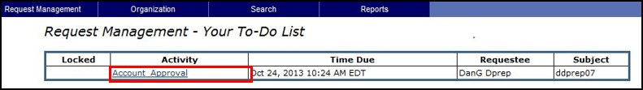

1. The *Approve/Reject the Request* page appears. Click **Approve**.
2. *The Request Management—Your Pending Requests* page appears.

# Summary

In this chapter, you learned:

* + The purpose of managing user accounts
  + How to identify users who are authorized to manage other user accounts
  + How to create a User ID
  + How to create, assign and edit an OTCnet account for a user
  + How to manage a user password
  + How to manage personal information
  + How to approve/reject an OTCnet user request
  + How to modify a user status